**Online Doctor Appointment and Consultation with Live Chat Application**

**Problem Statement:**

# Many deadly diseases are preventable and can be cured if treated at an early stage. However, people tend to ignore the early symptoms of a disease as they are mild. And till the time they become aware of the disease, the infection has already spread into their body. Hence, it is always advisable to have a regular body check-up to avoid health issues later. But due to day-to-day busy schedule many times it is not possible for the patients to go and get a medical appointment booked in person. Which leads to a delay in the treatment and may cause a major health problem later. The Online Doctor Application proposed here is an android based smart application that will help the users to identify a disease based on the symptoms. When a patient enters his /her symptoms the system will incorporate various machine learning & deep learning techniques to identify the disease. Then based on the disease identified the system will recommend a list of doctors having expertise on that particular disease. The patients can book an appointment with the doctors as per their preferred time & date. The patients can also chat with a doctor to get consultations.

# Working of the project:

# In this system, the admin can manage or view the details of doctors, patients, diseases and can also receive feedback from the patients. It also manages all the information of the doctor's schedule, doctor fees, and appointments for the doctor. The doctor can chat with the patients directly to keep track and be up to date about their health status. The patients can guess the disease by entering the symptoms they are suffering from and can also keep up-to-date knowledge about the new disease and its symptoms. If the user/patient is suffering from any of the diseases they can book an appointment for the same.

1. ***Project Life Cycle***

The iterative waterfall model is a classical model used in system development life cycle to create a system with a linear and sequential approach. It is termed as waterfall because the model develops systematically from one phase to another in downward fashion. The iterative waterfall approach define the process to go back to the previous phase to handle changes in requirement.

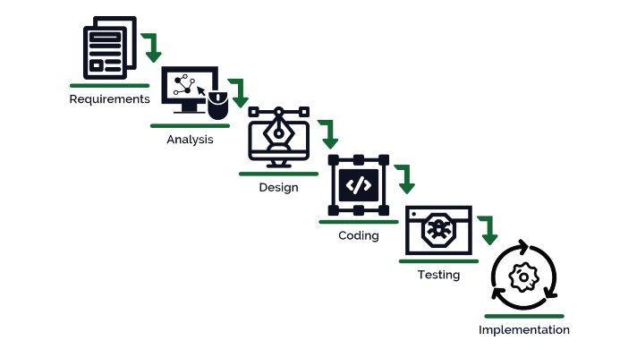

1. ***System Description***

The system comprises of 3 major modules with their sub-modules as follows:

**Admin**:

1. **Login**
   * + Admin can login in his personal account using id and password.
2. **Manage Doctor**

* Add new Doctors
* View current doctors
* Delete doctors

1. **Manage Disease**

* Add new disease
* View disease or its symptoms
* Edit details for the disease
* Delete disease
* Add/Update disease category

1. **View Patient**

* View patient details

1. **View Feedback**

* View feedback given by the patients and doctors

**Patient**:

1. **Register**

* User can register using personal details.

1. **Login**

* User/Patient can login in his personal account using id and password.

1. **Profile**

* view & update profile

1. **Search Disease**

* search diseases by name, type or symptoms
* view disease symptoms

1. **Doctor Details**
   * + - View profile of the doctors
       - View charges for the visit/consultation
       - Address of the doctor to visit
       - Book Appointment
2. **Chat**

* Chat with doctors
* List All Chats

1. **Book Appointment**
   * + - Select doctor for the appointment
       - Date of appointment
       - Time of the appointment
       - Charges for the appointment
2. **Note (if any)**
   * + - Check if doctor available or any other appointment book at entered time
       - Enter card details for the appointment
       - Wait for the confirmation from the doctor
       - If rejected the amount will be refunded
3. **View Appointment**
   * + - Check for current, pending, previous or other appointments
       - Book an appointment
4. **Transactions**
   * + - Record of the payment to the doctors debited or credited
       - If the appointment is accepted the amount will be debited and will appear in debited transactions
       - If the appointment is rejected the amount will be refunded back and will appear in credited transactions

**Doctor**:

1. **Login**

* Doctor can login in his personal account using id and password.

1. **My Details**

* view & update profile

1. **View Disease**

* view diseases by name, type or symptoms
* view disease symptoms

1. **View Patient**

* View profile of the patients
* Select user/patient from the list and can chat with selected user/patient

1. **Chat:**

* Chat with patients
* List All Chats

1. **Appointments**

* Check for current, pending, previous or other appointments
* Accept user/patient appointments if available

1. **Transactions**

* Record of the payment to the patients debited or credited
* If the appointment is accepted the amount will be credited and will appear in credited transactions
* If the appointment is rejected the amount will be refunded back to the user/patient and will appear in debited transactions

1. ***Feedback***

* Star Rating of the app
* User Experience
* Comments

# *Technology*

# PYTHON,

# Sqlite,

# HTML5,

# CSS,

# JAVASCRIPT,

# NodeJS,

# ReactJS,

# DJANGO,

# MACHINE LEARNING,

# ARTIFICIAL INTELLIGENCE